Entities and their attributes
- Movie
It will have the movie information and have the attributes: ID, Title, Catalog ID, Running Length, Genre ID, Director ID, Rating, Year Released.
- Catalog
It will have the information of movie catalog. The attributes would be: ID, Movie ID and Distributor ID.
- Distributor
It will have the information of movie distributor. The attributes would be ID, Name and Total Shipments.
- Shipment
It will have the shipment information. The attributes would be ID, Distributor ID, Quantity, and Price.
- VideoDVD
It will have the Video DVD information. The attributes would be ID, Distributor Serial Number, Movie ID and Video or DVD.
- Actor
It will have the information of Actors. The attributes would be ID, Name, Date of Birth and Gender.
- Director
It will have the information of Director. The attributes would be ID, Name, Date of Birth and Gender.
- Awards
It will have the information of Awards. The attributes would be ID, Actor ID, Director ID and Movie ID.
- Genre
It will have the Genre information of Movie. The attributes will be ID, Genre Name and Movie ID.
- Discount
It will have the discount information. The attributes would be ID, Move ID and Discount Value.
- Rentals
It will have the information of Movie Rentals. The attributes would be ID, Customer ID, Rental Date, Video DVD ID, Return Date, Late Fees, Failure to Rewind Fees and Taxes.
- Customer
It will have the information of Customers. The attributes would be ID, Name, Address, Phone, Monthly Rental, Annual Rental, and Total Rental.
- MovieStars
It will have the information of Movie Stars. The attributes would be Movie ID, Actor ID and Details.

Relationship Sentence Pairs
- VideoDVD – Rentals
A Video or DVD may have zero or more rentals
A Rental is of only one Video or DVD
- Rentals – Customer
A Customer may have one or more Rentals
A Rental is from only one Customer

- Movie – Genre
A Movie is of only one Genre
A Genre may be of one or more Movie
- Catalog – Distributor
Catalog has zero or more movies
Each Movie is from only one Catalog
- Distributor – Shipment
Each Shipment is from only one Distributor
A Distributor may have zero or more Shipments
- VideoDVD – Movie
Each Video or DVD is of only one Movie
A Movie may have one or more Video or DVD
- MovieStars – Actor
MovieStar may have only one Actor
An Actor can be of zero or more MovieStars
- Movie – Director
A Movie may have only one Director
A Director can be of one or more Movie
- Movie – Discount
A Movie may have zero or more Discount
Discount can only be on one Movie
- Movie – MovieStars
Movie may have one or more Movie Stars
MovieStars can only be of one Movie

- Awards – Movie
A Movie may have zero or more Awards
An Award can be of only one Movie
- Awards – Director
A Director may have zero or more Awards
An Award can be of zero or one Director
- Awards – Actor
An Actor may have zero or more Awards
An Award can be of zero or one Actor

ER Diagram

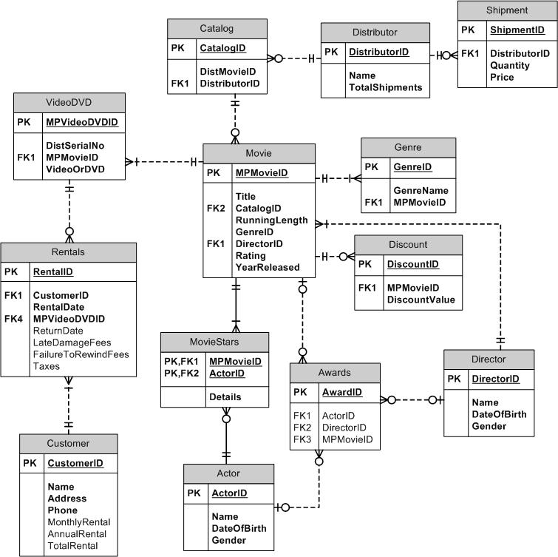

SQL DDL
CREATE TABLE Customer(
CustomerID INT PRIMARY KEY,
Name VARCHAR(20),
Address VARCHAR(50),
Phone VARCHAR(15),
MonthlyRental NUMERIC,
AnnualRental NUMERIC,
TotalRentail NUMERIC
);

CREATE TABLE Distributor(
DistributorID INT PRIMARY KEY,
Name VARCHAR(20),
TotalShipments INT
);

CREATE TABLE Shipment(
ShipmentID INT PRIMARY KEY,
DistributorID INT,
Quantity INT,
Price NUMERIC,
CONSTRAINT fk_shipDist FOREIGN KEY (DistributorID)
REFERENCES Distributor(DistributorID)
);

CREATE TABLE [Catalog](
CatalogD INT PRIMARY KEY,
DisMovieID INT,
DistributorID INT,
CONSTRAINT fk_CatDist FOREIGN KEY (DistributorID)
REFERENCES Distributor(DistributorID)
);
CREATE TABLE Genre(
GenreID INT PRIMARY KEY,
GenreName VARCHAR(20),
);

CREATE TABLE Director(
DirectorID INT PRIMARY KEY,
Name VARCHAR(20),
DateOfBirth DATE,
Gender CHAR(1)
);
CREATE TABLE Movie(
MPMovieID INT PRIMARY KEY,
Title VARCHAR(30),
CatalogID INT,
RunningLength INT,
GenreID INT,
DirectorID INT,
Rating NUMERIC,
YearReleased INT,
CONSTRAINT fk_MovCat FOREIGN KEY(CatalogID)
REFERENCES Catalog(CatalogD),
CONSTRAINT fk_MovGen FOREIGN KEY(GenreID)
REFERENCES Genre(GenreID),
CONSTRAINT fk_MovDir FOREIGN KEY(DirectorID)
REFERENCES Director(DirectorID)
);
CREATE TABLE Discount(
DiscountID INT PRIMARY KEY,
MPMovieID INT,
DiscountValue NUMERIC,
CONSTRAINT fk_discMov FOREIGN KEY (MPMovieID)
REFERENCES Movie(MPMovieID)
);

CREATE TABLE VideoDVD(
MPVideoDVDID INT PRIMARY KEY,
DistSerailNo INT,
MPMovieID INT,
VideoOrDVD INT,
CONSTRAINT fk_vidMov FOREIGN KEY(MPMovieID)
REFERENCES Movie(MPMovieID)
);

CREATE TABLE Rentals(
RentalID INT PRIMARY KEY,
CustomerID INT,
RentalDate DATE,
MPVideoDVDID INT,
ReturnDate DATE,
LateDamageFees NUMERIC,
FailureToRewindFees NUMERIC,
Taxes NUMERIC,
CONSTRAINT fk_rentCust FOREIGN KEY(CustomerID)
REFERENCES Customer(CustomerID),
CONSTRAINT fk_rentDVD FOREIGN KEY(MPVideoDVDID)
REFERENCES VideoDVD(MPVideoDVDID)
);

CREATE TABLE Actor(
ActorID INT PRIMARY KEY,
Name VARCHAR(20),
DateOfBirth DATE,
Gender CHAR(1)
);

CREATE TABLE Awards(
AwardID INT PRIMARY KEY,
ActorID INT,
DirectorID INT,
MPMovieID INT,
CONSTRAINT fk_AwAct FOREIGN KEY(ActorID)
REFERENCES Actor(ActorID),
CONSTRAINT fk_AwDir FOREIGN KEY(DirectorID)
REFERENCES Director(DirectorID),
CONSTRAINT fk_AwMv FOREIGN KEY(MPMovieID)
REFERENCES Movie(MPMovieID),
);

CREATE TABLE MovieStars(
MPMovieID INT,
ActorID INT,
Details VARCHAR(50),
CONSTRAINT pk_star PRIMARY KEY(MPMovieID, ActorID),
CONSTRAINT fk_StMov FOREIGN KEY(MPMovieID)
REFERENCES Movie(MPMovieID),
CONSTRAINT fk_StAct FOREIGN KEY(ActorID)
REFERENCES Actor(ActorID)
);
SQL DML Insert Statements
INSERT INTO Customer
VALUES(1, ' Tiara Dragoo', '7944 New Ave.Langhorne, PA 19047', '9855655485', 20,520, 562);
INSERT INTO Customer
VALUES(2, 'Luci Hudkins', '889 10th Street Waterloo, IA 50701', '956625212', 10,100, 230);
INSERT INTO Customer
VALUES(3, 'Shanelle Micheal', '745 Hillcrest Street Missoula, MT 59801', '965846212', 0,0, 0);
INSERT INTO Customer
VALUES(4, 'Joanie Mirelez', '9693 Thompson Ave. Kennewick, WA 99337', '9652266255', 14,25, 30);
INSERT INTO Customer
VALUES(5, 'Odell Buchwald', '779 Branch Drive Warwick, RI 02886', '9655224568', 5,20, 78);

INSERT INTO Distributor
VALUES(1, 'Izola Devereux', 30);
INSERT INTO Distributor
VALUES(2, 'Dayle Haga', 65);
INSERT INTO Distributor
VALUES(3, 'Doretta Bixby', 8);
INSERT INTO Distributor
VALUES(4, 'Gustavo Gassert', 25);
INSERT INTO Distributor
VALUES(5, 'Candie Maddock', 68);

INSERT INTO Shipment
VALUES(1, 2, 23, 230);
INSERT INTO Shipment
VALUES(2, 1, 30, 320);
INSERT INTO Shipment
VALUES(3, 5, 24, 210);
INSERT INTO Shipment
VALUES(4, 3, 56, 1200);
INSERT INTO Shipment
VALUES(5, 4, 35, 350);

INSERT INTO [Catalog]
VALUES(1, 2, 3);
INSERT INTO [Catalog]
VALUES(2, 1, 4);
INSERT INTO [Catalog]
VALUES(3, 3, 5);
INSERT INTO [Catalog]
VALUES(4, 4, 1);
INSERT INTO [Catalog]
VALUES(5, 5, 2);

INSERT INTO Genre
VALUES(1, 'Action');
INSERT INTO Genre
VALUES(2, 'Comedy');
INSERT INTO Genre
VALUES(3, 'Drama');
INSERT INTO Genre
VALUES(4, 'Romance');
INSERT INTO Genre
VALUES(5, 'Horror');
INSERT INTO Director
VALUES(1, 'Irwin Zylstra', '1950-10-10', 'F');
INSERT INTO Director
VALUES(2, 'Lorrine Robertson', '1958-02-13', 'M');
INSERT INTO Director
VALUES(3, 'Rena Prine', '1968-02-15', 'M');
INSERT INTO Director
VALUES(4, 'Lynelle Cipriani', '1988-08-10', 'M');
INSERT INTO Director
VALUES(5, 'Leroy Englehart', '1972-02-21', 'F');

INSERT INTO Movie
VALUES(1, 'The Godfather', 2, 210, 2, 1, 8, 1980);
INSERT INTO Movie
VALUES(2, 'Raging Bull', 1, 180, 2, 3, 7, 1957);
INSERT INTO Movie
VALUES(3, 'Casablanca', 5, 150, 2, 2, 9, 1975);
INSERT INTO Movie
VALUES(4, 'Citizen Kane', 4, 85, 2, 4, 8, 1968);
INSERT INTO Movie
VALUES(5, 'The Wizard Of Oz', 3, 90, 2, 5, 6, 1987);

INSERT INTO Discount
VALUES(1, 2, 5.2);
INSERT INTO Discount
VALUES(2, 3, 0);
INSERT INTO Discount
VALUES(3, 1, 10);
INSERT INTO Discount
VALUES(4, 5, 5.5);
INSERT INTO Discount
VALUES(5, 4, 2.5);

INSERT INTO VideoDVD
VALUES(1, 2, 3, 1);
INSERT INTO VideoDVD
VALUES(2, 5, 4, 1);
INSERT INTO VideoDVD
VALUES(3, 4, 2, 2);
INSERT INTO VideoDVD
VALUES(4, 1, 1, 2);
INSERT INTO VideoDVD
VALUES(5, 3, 5, 1);

INSERT INTO Rentals
VALUES(1, 2, '2012-05-14', 2, '2012-05-20', 0, 1, 0.8);
INSERT INTO Rentals
VALUES(2, 1, '2012-06-12', 2, '2012-06-14', 2, 2, 0.5);
INSERT INTO Rentals
VALUES(3, 4, '2012-07-11', 2, '2012-07-20', 2.5, 1, 1);
INSERT INTO Rentals
VALUES(4, 5, '2012-08-05', 2, '2012-08-07', 0, 2, 1.3);
INSERT INTO Rentals
VALUES(5, 3, '2012-08-28', 2, '2012-09-02', 1.3, 3, 0.82);

INSERT INTO Actor
VALUES(1, 'Christel Yaple', '1980-05-12', 'F');
INSERT INTO Actor
VALUES(2, 'Marvis Garnica', '1985-02-08', 'M');
INSERT INTO Actor
VALUES(3, 'Ouida Caiazzo', '1947-05-10', 'F');
INSERT INTO Actor
VALUES(4, 'Peggy Kotek', '1965-04-21', 'M');
INSERT INTO Actor
VALUES(5, 'Anjanette Neidig', '1973-02-28', 'M');

INSERT INTO Awards
VALUES(1, 2, 4, 1);
INSERT INTO Awards
VALUES(2, 3, 5, 4);
INSERT INTO Awards
VALUES(3, 5, 3, 5);
INSERT INTO Awards
VALUES(4, 1, 1, 2);
INSERT INTO Awards
VALUES(5, 4, 2, 4);

INSERT INTO MovieStars
VALUES(1, 2, 'Lead');
INSERT INTO MovieStars
VALUES(2, 1, 'Support');
INSERT INTO MovieStars
VALUES(3, 5, 'Negative');
INSERT INTO MovieStars
VALUES(4, 4, 'Lead');
INSERT INTO MovieStars
VALUES(5, 3, 'Support');

SQL Queries
Query a.
SELECT * FROM Customer;
SELECT * FROM Distributor;
SELECT * FROM Shipment;
SELECT * FROM [Catalog];
SELECT * FROM Genre;
SELECT * FROM Director;
SELECT * FROM Movie;
SELECT * FROM Discount;
SELECT * FROM VideoDVD;
SELECT * FROM Rentals;
SELECT * FROM Actor;
SELECT * FROM Awards;
SELECT * FROM MovieStars;

Query b.
SELECT CustomerID, Name, Address
FROM Customer
ORDER BY CustomerID;

Query c.
SELECT * FROM Rentals
WHERE DATEDIFF(d, RentalDate, GETDATE()) <= 30
ORDER BY RentalDate;

Query d.
UPDATE Customer
SET Name = 'Luci Smith'
WHERE CustomerID = 2;

Query e.
DELETE FROM Customer
WHERE CustomerID = 2;

